# Chapter 1 : Introduction of Computer

## About Computer

Computer is an electronic, programmable, automatic machine which accept data through input devices, store and process them, and resulted data are displayed in output devices.

At present, computer is taken as the most powerful electronic device. It can be use while processing large amount of data and information. It never gets tired or bored instead it can perform repetitive tasks.

## Importance

Computer is a most useful device in present context. So, without computers we cannot do anything. Computers are used in various places such as in Bank, School, Hospital, Industries, Research, Data processing, Science and engineering, Offices, Business Advertisement, Library, Weather forecasting, Airline Corporation ,etc. It is used in bank for providing customer services such as: ATM, EFTS, etc. It is used to forecast weather, to maintain the record of updated books, helps in communication, helps in making the design of bridges, helps in data processing, helps in preparing reports, word processing, etc.

## Objectives

The main objectives are as follows;

1. The students can help improve the competitiveness of enterprises in our country through the use and development of appropriate technologies.
2. It aims at researching the best practices, evaluate, consulting and teaching about new software technologies available.
3. It helps to strengthen research and publications in scientific journals.
4. It plans to build new laboratories to enable the study and development of new technologies.

# Chapter 2 : Introduction to HTML:

## 2.1. About HTML

HTML stands for Hyper Text Markup Language which is used for describing web pages. It is a language used for creating Web Pages containing text, graphics, animation, sound, video and interactive elements.

It is a standard set of codes, called tags, used to format all Web Pages. The HTML provides a set of rules defining the way tags can be used and combined. It is a document containing HTML tags and plain text. Learning the HTML means learning the tags and rules.

## 2.2. Types of Tags:

The HTML tags are the keywords surrounded by angle brackets; used to describe the content of web page. It has three sections:

1. Tag name
2. Attributes
3. Value of attributes

Example:

<BODY bgcolor=”black” text=”green”>

(In this example the BODY is the tag name, bgcolor and text are the attributes and the green are the values.)There are two types of tags:

1. Paired tags :

It has two parts the opening and the closing.

* An opening tag is a tag that indicates the start of the HTML commands. It always begins with <….>.
* A closing tag is a tag that indicates the end of the HTML commands. It always begins with </…..>.

1. Singular tags:

It is a single type of tag that does not have any ending tag. It issues an HTML command without enclosing any text in the page.

Example: <br>, <hr> etc.

## 2.3. Basic Structure of HTML:

**<html>**

**<head>**

**<title>……………………</title>**

**</head>**

**<body>**

**……………………………………….**

**………………………………………**

**</body>**

**</html>**

**Fig 1 : Basic Structure Of HTML**

Attributes used in body tag:

|  |  |  |
| --- | --- | --- |
| Attributes | Values | Description |
| Bgcolor | Color name/ color code | To specify the background color of webpage |
| Background | url of image | To specify image file background image of page |
| Text | Color name/ color code | To specify the color of text in a webpage |
| Link | Color name/ color code | To specify the color of hyper link before clicking |
| Alink | Color name/ color code | To specify the color of active link |
| Vlink | Color name/ color code | To specify the color of visited link |
| Top margin | Number in pixel | To specify top margin of page |
| bottom margin | Number in pixel | To specify bottom margin of page |

**Table 1 : Attributes used in body tag**

## Character Formatting:

## Paragraph:

The <p> tag is used to specify the paragraph. When the user uses this tag the computer automatically adds a blank line before and after writing a paragraph.

|  |  |  |
| --- | --- | --- |
| Attribute | Value | Description |
| Align | Left/right/center | To specify the alignment of the paragraph |

**Table 2 : Attributes, Value, Description used in Paragraph Tag**

{Note: If no alignment is defined for the paragraph then by default the paragraph comes on the left side.}

## Heading:

It is a simple form of text formatting according to heading’s level. It contains of six elements (H1 to H6). To get the biggest heading <H1> tag is used in front of the text the user desires to make as a heading and ends it with </H1> tag; likewise if a smaller heading is needed then <H2>…</H2> tag is used and for even smaller and smaller headings <H3>/<H4>/<H5>.

To create the smallest heading <H6> tag is used.

## Font:

<Font> this tag is used to specify the font color, size and name.

|  |  |  |
| --- | --- | --- |
| Attributes | Values | Description |
| Face | Font name | To specify the font of text |
| Color | Color name/color code | To specify the color of text |
| Size | 1 to 7 | To specify the font size, default is 3. |

**Table 3 : Attributes, Values, Description of Font**

## 2.4. List:

Lists are used to group related pieces of information together, so they are clearly associated with each other and are easy to read. The html has three types of list:

1. Ordered list
2. Unordered list
3. Description list

## Ordered list:

It is a type of list that is used to group a set of related items in a specific order. This is defined in html by <ol>……. </ol> tag. Every item in this list begins with a sequence number. Each item is inserted with <li>…</li> tag that creates a line break and inserts a number at the beginning.

|  |  |  |
| --- | --- | --- |
| Attributes | Values | Description |
| Type | 1/I/I/a/A | Type of numbered list. |
| Start | Number | Starting value of the numbering. |

**Table 4 : Attributes, Values, Description used in Ordered List**

## Unordered list:

It can be also known as bulleted list. This list groups a set of related items together but does not list it in a particular order. It is defined by <ul>…..</ul> tag. In this list every item begins with a bulletin mark in the beginning.

|  |  |  |
| --- | --- | --- |
| Attributes | Values | Descriptions |
| Type | Disc/circle/square | Used to specify the type of bulleted list. |

**Table 5 : Attributes, Values, Description used in Unordered List**

## Description list:

It is a type of list that is used to display name/values pairs such as their terms and definitions etc. This list is different from other kinds of list, as they use name and values instead of list items. Description list is defined by <dl>…. </dl> elements. The <dl> tag is used with conjunction <dt>….</dt> to define names/terms and <dd>….</dd> to define <terms/values>.

## Nested list:

A nested list is a list occurring in the bound of another list nesting the new list inside the original.Example:

<html>

<head>

<title>……</title>

</head>

<body>

<b>classification software</b>

<ol>

<li>…..</li>

<ol type=”a” start=”3”>

<li>……</li>

</ol>

<li>……</li>

<ul type=”square”>

<li>….</li>

<li>…..</li>

</ul>

</ol>

</body>

</html>

## Hyperlink:

Hyperlink is a component of web that is used to jump from one piece of information to another. The piece of information can either be of the same page or on a different web page. When the cursor is moved over to a link then the cursor turns into a small hand.

An anchor<a> element is used to define a link and its important attribute is the href that indicates the link’s destination.

|  |  |  |
| --- | --- | --- |
| Attributes | Values | Descriptions |
| Href | url of webpage or name of bookmark. | To indicate the linked destination |
| Target | _blank  _parent  _self  _top | To specify where to open the linked document. |
| Name(or id) | Section name(user defined) | For specifying specific point  on a page. |

**Table 6 : Attributes, Values, Descriptions used in Hyperlink**

Different types of link:

## External link:

It is a link used to jump to different WebPages or websites.

Example:

<html>

<head>

<title> external link</title>

</head>

<body alink=”green” link=”red” vlink=”brown”>

<ul>

<li><a href=”<http://www.google.com>”>[www.google.com](http://www.google.com)</li>

</ul>

</body>

</html>

## Internal link:

It is a link used to jump from one part of page to another part of the same page. For this a location on a page is marked by using name attribute in a <a> tag. Example:

<html>

<head>

<title> internal link</title>

</head>

<body>

<a name=”movie”></a>

<a href=”#book”>click here to go to books </a>

<pre>

Kung Fu panda

</pre>

<a name=”books”></a>

<a href=”#movie”> click here to go to movie </a>

<pre>

Fault in our stars

</pre>

</body>

</html>

## Mail link:

It is used to link e-mail address. The value of href attribute for mail link is <mailto:emailsddress>

Example:

<a href=” <mailto:niki.stha@gmail.com>”>[niki.stha@gmail.com](mailto:niki.stha@gmail.com)</a>

## 2.5. Concept of CSS:

CSS stands for cascading style sheets that allows us to specify the style of our page elements differently from the structure of the original document. This separation of structure makes easy to manage and easy to change the style of the document.

The CSS has its different types such as:

## Inline style:

It is the one in which an individual elements style is declared using the style attributes.

Example:

<html>

<head>

<title> inline style</title>

</head>

<body>

<p>…………………</p>

<p style=”font-size:20pt”>……………..</p>

<p style=”font-size:20pt; color: red; margin-left:20pt”>………..</p>

</body>

</html>

## Internal style sheet:

It is used when an entire document has an unique style. It is defined by the <style> tag in the head section.Example:

<html>

<head>

<title> internal style sheet </title>

<style type=”text/css”>

H1 {font-family: Arial, sans-serif}

Em {background-color:#800ff; color:white}

P {font-size:36pt; color:green}

.blue {color: blue}

</style>

<body>

<h1 class=”blue”>…. </h1>

<hr>

<p>…………………….

……………. </p>

<p class=”blue”>…………….

<em>……………………. </em></p>

</body>

</html>

## External style sheet:

It gives the whole website a uniform look. Separate pages of sites can utilize the same style sheet. To change the style of the whole work changing only a single file is enough for that all the websites must be linked with the help of <link> tag.

Example:

A {text-decoration: none}

A: hover {text-decoration: underline; margin-left: 5cm}

Li EM {color: red; font-weight: bold}

UL {margin-left: 2cm}

UL UL {text-decoration: underline; margin-left: 5cm}

[save the file with .css extension as stylesheet.css]

[now creating a new web page]

<html>

<head>

<title> external style sheet </title>

<link rel=”stylesheet” type=”text/css” href=”stylesheet.css”>

</head>

<body>

<h1>……. <em> … </em></h1>

<ul>

<li>….. </li>

<li>…..</li>

<ul>

<li>…. </li>

<li>…. </li>

</ul>

<a href=”http://www.abcd.com”> ……. </a>

</ul>

</body>

</html>

# Chapter 3 : Introduction of the project

## About Project

This Project is about "Computer Services". It was established in 2063 B.S. in Newroad, Kathmandu. All kind of tools and equipments of computer and laptop are available easily.

## Scope

Its scopes are :

1. This provides more opportunity for computer mechanic.
2. To make easily available of computer part in each and every sector.
3. Develops computer system in Nepal.

## Limitation

Its limitations are;

1. Provides minimum opportunity to computer mechanic.
2. Qualified Computer Mechanic are required.
3. The charging fee of computer is high so every people cannot afford it.

# 4. HTML Coding and Output

## 4.1. HTML Codes

**Our Services**

**Home Page**

**Introduction**

<html>

<head>

<title> Computer Services</title>

<link rel="stylesheet" href="style.css">

</head>

<body>

<header>

<nav>

<h1><img src="5.jpg" width="20px" height="30px">Computer Services</h1>

<ul id="nav">

<li>

<a class="homered" href="home.html">Home</a>

<a class="homeblack" href="service.html">Our services</a>

<a class="homeblack" href="contact.html">Contact</a>

</li>

</ul>

</nav>

</header>

<div class="divider"></div>

<h2 class="color">Computer Service and support the Easy way!</h2>

<h3 class="color">On Site Service</h3>

<p align="left" class="color">Our on site computer support makes getting your computer fixed easy! No need to disconnect all those computer cables,load it into the car, and drop it off at a repair shop. One of our friendly technicians will come right to your home or business and repairs your computer on the spot. We service areas of Manamaiju, Balaju and beyond! </p>

<h3 class="color">Remote Support</h3>

<p align="left" class="color">Our quick and easy remote support is availabe to residental and business clients. We can solve most software issues relatively quickly and no need for specific on site appointments, sticking around the house or, interrupting the office during the work day. Click here to get started.</p>

<h3 class="color">Business IT Services</h3>

<p align="left" class="color">Whether it is a quick fix or a monthly services to ensure business continuity and a covered. We offer services including:

<ul type="disc">

<li class="color">Cloud Managed Antivirus and Firewall Protection</li>

<li class="color">Cloud Managed Online Backup</li>

<li class="color">Remote Management and Monitoring</li>

</ul>

</p>

<h3 class="color">About us</h3>

<p align="justify" class="color">Our unique on-site service is proof that customers love the convenience of having a technician come right to their home or business to service their computer. Offering this service at a low cost within our service area of Stratford, Milverton, Mitchell & St. Marys makes us the provider of choice for all your computer needs. </p>

<br>

<div class="footer">

<h1>Follow or Contact us on 01-42261</h1><br>

<a href="https://www.facebook.com"><img src="face.png" width="30" height="30"></a>

<a href="https://www.google.com"><img src="google.png" width="30" height="30"></a>

<a href="https://www.instagram.com"><img src="instagram.png" width="30" height="30"></a>

<a href="https://www.twitter.com"><img src="twitter.png" width="30" height="30"></a>

<a href="https://www.youtube.com"><img src="youtube.png" width="30" height="30"></a>

</div>

</body>

</html>

**Output of Home Page**

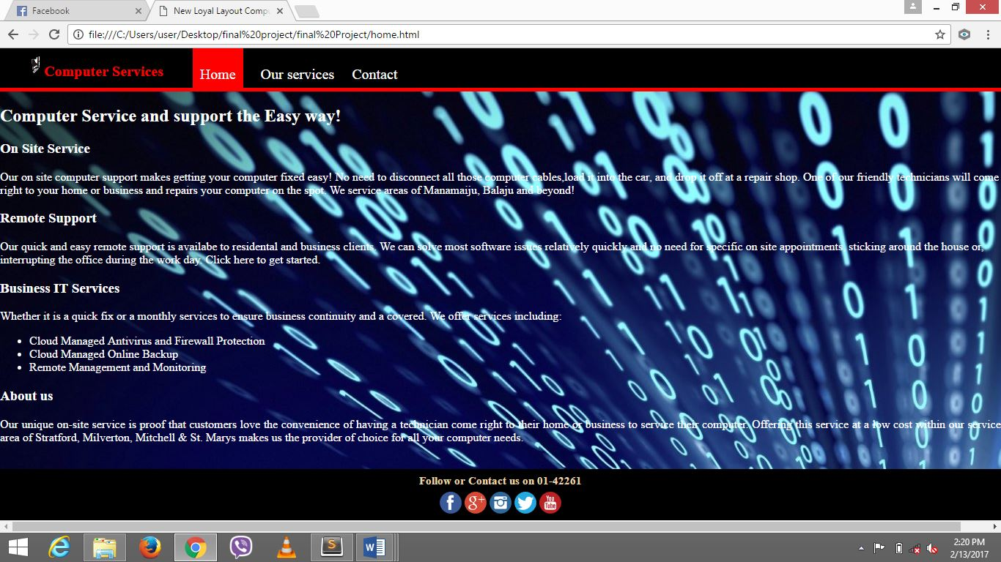

**Fig 2 : Home Page**

**Our Services**

<html>

<head>

<title>Computer Services</title>

<link rel="stylesheet" href="style.css">

</head>

<body>

<header>

<nav>

<h1><img src="5.jpg" width="20px" height="30px">Computer Services</h1>

<ul id="nav">

<li>

<a class="homered" href="home.html">Home</a>

<a class="homeblack" href="service.html">Our services</a>

<a class="homeblack" href="contact.html">Contact</a>

</li>

</ul>

</nav>

</header>

<div class="divider"></div>

<h2 class="color">Our Services</h2>

<p align="justify" class="color">IT-Works focuses on providing a high level of customer service and fast turnaround times for home, business, and agricultural customers. For your convenience we offer 3 types of services:

<ul type="disc" class="color">

<li>Remote Computer Support where we simply your computer remotely and share control of your screen.</li>

<li>On site servicces in the areas of Manamaiju, Balaju and beyond!</li>

<li>Of course you can also bring your computer to us just east of rostock, ON</li>

</ul>

</p>

<h3 class="color">Repair Services:</h3>

<p align="justify" class="color">

<ul type="disc">

<li class="color"><a href="hardware repair.html">Hardware repair</a> </li>

<li class="color">Backup Solutiuon</li>

<li class="color"><a href="antivirus software.html">Antivirus Software</a></li>

<li class="color"><a href="computer cleaning and optimization.html">Computer cleaning and optimization.</a></li>

<li class="color">Installation of Windows VISTA, 7, 8, 8.1, 10</li>

<li class="color">Printing issues </li>

<li class="color">Computer not starting up or blue screen error</li>

<li class="color">No connection of Internet</li>

<li class="color">Wireless network set-up </li>

<li class="color">Set up and transfer files to your new computer.</li>

<li class="color"><a href="hardware data recovery.html">Data recovery</a></li>

<li class="color"><a href="website design.html">Website design and maintenance</a></li>

</ul>

</p>

<br>

<p class="color">Call 01-42261 to set up an appointment today!</p>

<div class="footer">

<h1>Follow or Contact us on 01-42261</h1>

<br>

<a href="https://www.facebook.com"><img src="face.png" width="30" height="30"></a>

<a href="https://www.google.com"><img src="google.png" width="30" height="30"></a>

<a href="https://www.instagram.com"><img src="instagram.png" width="30" height="30"></a>

<a href="https://www.twitter.com"><img src="twitter.png" width="30" height="30"></a>

<a href="https://www.youtube.com"><img src="youtube.png" width="30" height="30"></a>

</div>

</body>

</html>

**Output of Our Services**

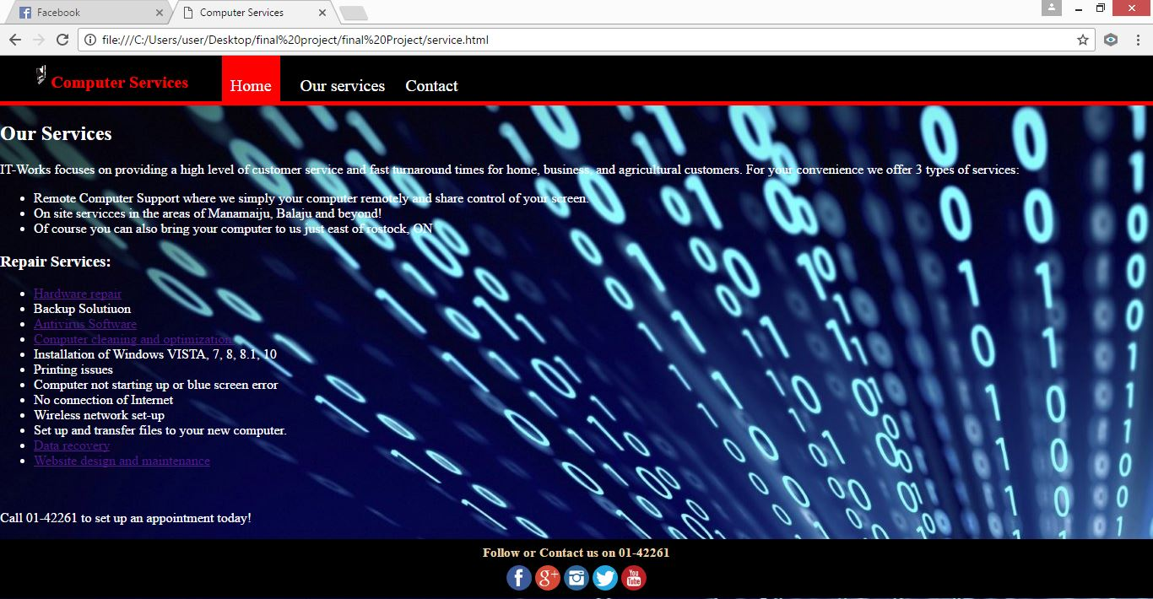

**Fig 3 : Our Services**

**Our Services**

**Hardware Repair**

<html>

<head>

<title>Hardware Repair</title>

<link rel="stylesheet" href="style.css">

</head>

<body>

<header>

<nav>

<h1><img src="5.jpg" width="50px" height="40px">Computer Services</h1>

<ul id="nav">

<li>

<a class="homered" href="home.html">Home</a>

<a class="homeblack" href="service.html">Our services</a>

<a class="homeblack" href="contact.html">Contact</a>

</li>

</ul>

</nav>

</header>

<div class="divider"></div>

<h2 class="color">Hardware Repair Include :</h2>

<ul type="disc">

<li class="color">

Laptop screen replacments, laptop batteries, laptop DC charging jacks, Laptop keyboard.

</li>

<li class="color">Hard drive replacemaent, video cards, motherboard, power supplies, RAM memory modules, etc.</li>

</ul>

<img src="22.jpg" width="200px" height="200px">

<img src="23.jpg" width="175px" height="200px">

<img src="25.jpg" width="175px" height="200px">

<img src="40.jpg" width="175px" height="200px">

<img src="41.jpg" width="200px" height="200px">

<img src="42.jpg" width="200px" height="200px">

<img src="43.jpg" width="200px" height="200px">

<img src="45.jpg" width="200px" height="200px">

<img src="46.jpg" width="200px" height="200px">

<img src="48.jpg" width="200px" height="200px">

<img src="49.jpg" width="200px" height="200px">

<img src="50.jpg" width="175px" height="200px">

<img src="53.jpg" width="175px" height="200px">

<img src="47.jpg" width="175px" height="200px">

<div class="footer">

<h1>Follow or Contact us on</h1>

<br>

<a href="https://www.facebook.com"><img src="face.png" width="30" height="30"></a>

<a href="https://www.google.com"><img src="google.png" width="30" height="30"></a>

<a href="https://www.instagram.com"><img src="instagram.png" width="30" height="30"></a>

<a href="https://www.twitter.com"><img src="twitter.png" width="30" height="30"></a>

<a href="https://www.youtube.com"><img src="youtube.png" width="30" height="30"></a>

</div>

</body>

</html>

**Output Of Hardware Repairs and Antivirus Software**

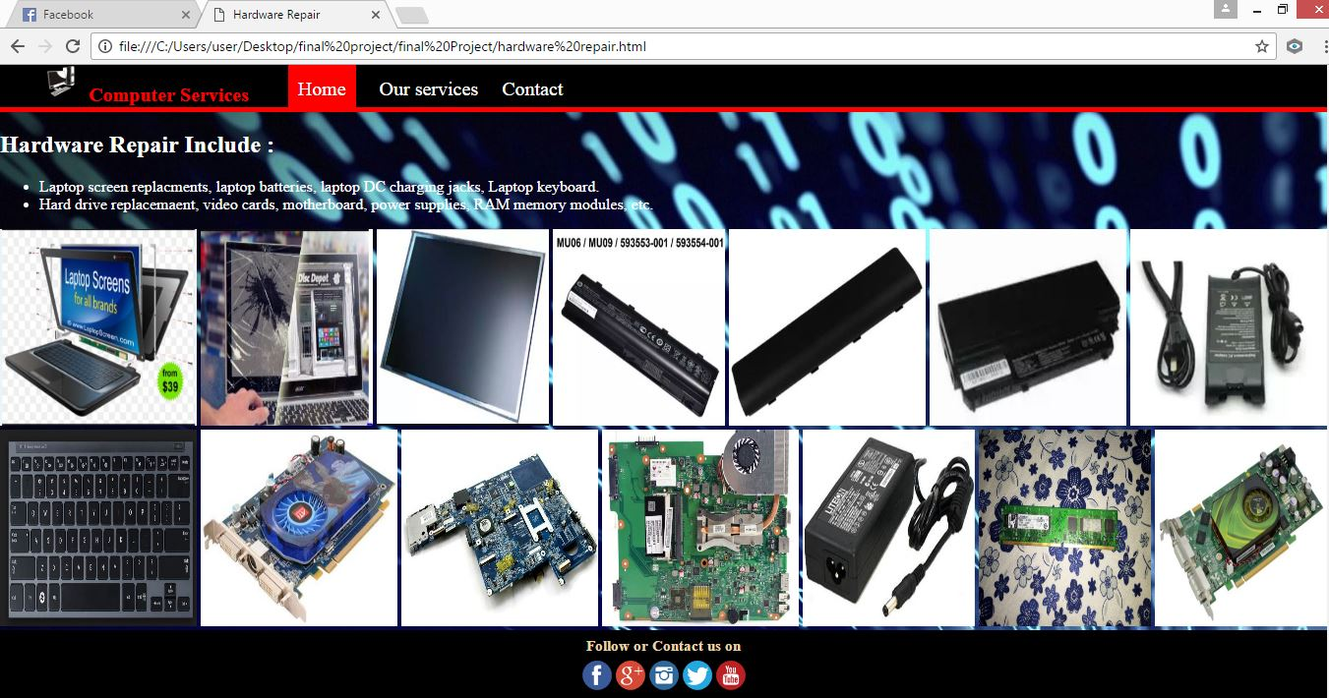

**Fig 4 : Hardware Repairs**

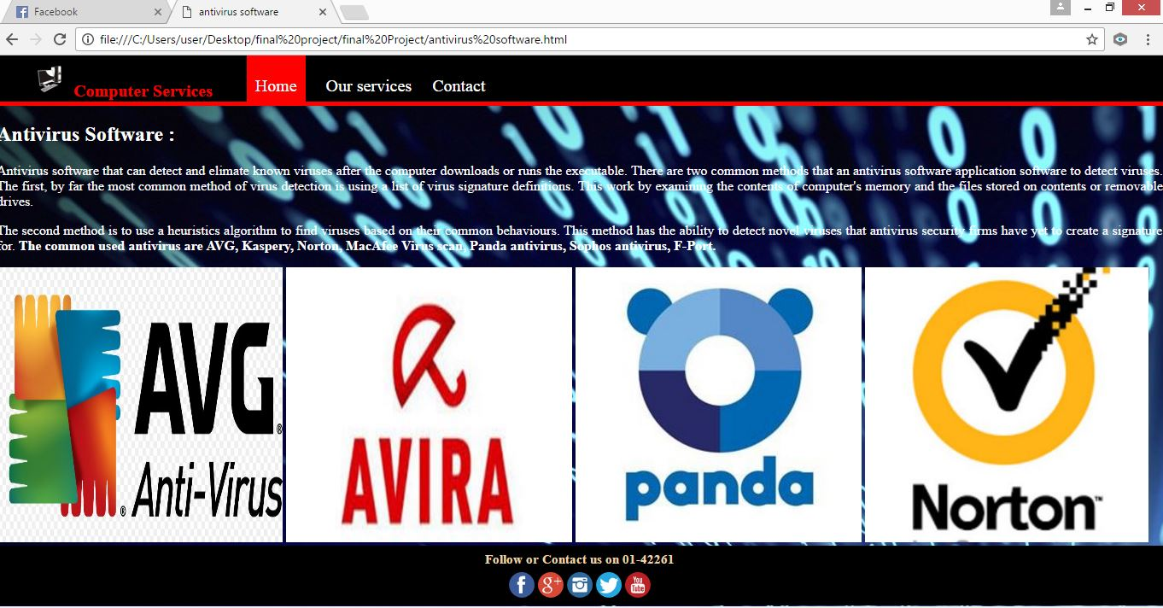

**Fig 5 : Antivirus Software**

**Our Services**

**Antivirus Software**

<html>

<head>

<title>antivirus software</title>

<link rel="stylesheet" href="style.css">

</head>

<body>

<header>

<nav>

<h1><img src="5.jpg" width="50px" height="40px">Computer Services</h1>

<ul id="nav">

<li>

<a class="homered" href="home.html">Home</a>

<a class="homeblack" href="service.html">Our services</a>

<a class="homeblack" href="contact.html">Contact</a>

</li>

</ul>

</nav>

</header>

<div class="divider"></div>

<h2 class="color">Antivirus Software :</h2>

<p align="justify" class="color">Antivirus software that can detect and elimate known viruses after the computer downloads or runs the executable. There are two common methods that an antivirus software application software to detect viruses. The first, by far the most common method of virus detection is using a list of virus signature definitions. This work by examining the contents of computer's memory and the files stored on contents or removable drives.</p>

<p align="justify" class="color">The second method is to use a heuristics algorithm to find viruses based on their common behaviours. This method has the ability to detect novel viruses that antivirus security firms have yet to create a signature for. <b class="color">The common used antivirus are AVG, Kaspery, Norton, MacAfee Virus scan, Panda antivirus, Sophos antivirus, F-Port.</b></p>

<img src="60.jpg" width="335px" height="322px">

<img src="61.jpg" width="335px" height="322px">

<img src="64.jpg" width="335px" height="322px">

<img src="63.jpg" width="332px" height="322px">

<div class="footer">

<h1>Follow or Contact us on 01-42261</h1>

<br>

<a href="https://www.facebook.com"><img src="face.png" width="30" height="30"></a>

<a href="https://www.google.com"><img src="google.png" width="30" height="30"></a>

<a href="https://www.instagram.com"><img src="instagram.png" width="30" height="30"></a>

<a href="https://www.twitter.com"><img src="twitter.png" width="30" height="30"></a>

<a href="https://www.youtube.com"><img src="youtube.png" width="30" height="30"></a>

</div>

</body>

</html>

**Our Services**

**Computer Cleaning and Optimization**

<html>

<head>

<title>Computer Services</title>

<link rel="stylesheet" href="style.css">

</head>

<body>

<header>

<nav>

<h1><img src="5.jpg" width="20px" height="30px">Computer Services</h1>

<ul id="nav">

<li>

<a class="homered" href="home.html">Home</a>

<a class="homeblack" href="service.html">Our services</a>

<a class="homeblack" href="contact.html">Contact</a>

</li>

</ul>

</nav>

</header>

<div class="divider"></div>

<h2 class="color">Computer Cleaning And Optimization</h2>

<p align="justify" class="color"> In computer science, program optimization is the process of modifying a software system to make some aspects of it work more efficently or use fewer resources.</p>

<p align="justify" class="color">Optimization can reduce readability and add code that is used only to improve the performance. This may complicate programs or systems, making them harder to maintain and debug. As a result, optimization is often performed at the end of the development stage</p>

<h2 class="color">Hard Drive Optimization</h2>

<p align="justify" class="color">If you uninstall a program, more than likely the folder for that program is still on the hard drive and referenced in the registry. If you browse the Internet, temporary Internet files are chaced on the system. Some of the cached files are okay because they are intended to make web browsing faster by not having to download an entire webpage every time is viewed. The problem is that it also stores files if you only go to a website once and those files are uncessary and will slow the computer down. A good computer optimization program will remove the uncessary clutter on the hard drive thus optimizing the computer.</p>

<center><img src="54.jpg" width="400px" height="240px"></center><div class="footer"> <h1>Follow or Contact us on 01-42261</h1>

<br>

<a href="https://www.facebook.com"><img src="face.png" width="30" height="30"></a>

<a href="https://www.google.com"><img src="google.png" width="30" height="30"></a>

<a href="https://www.instagram.com"><img src="instagram.png" width="30" height="30"></a>

<a href="https://www.twitter.com"><img src="twitter.png" width="30" height="30"></a>

<a href="https://www.youtube.com"><img src="youtube.png" width="30" height="30"></a>

</div>

</body>

</html>

**Output of Computer Cleaning and Optimization and Data Recovery**

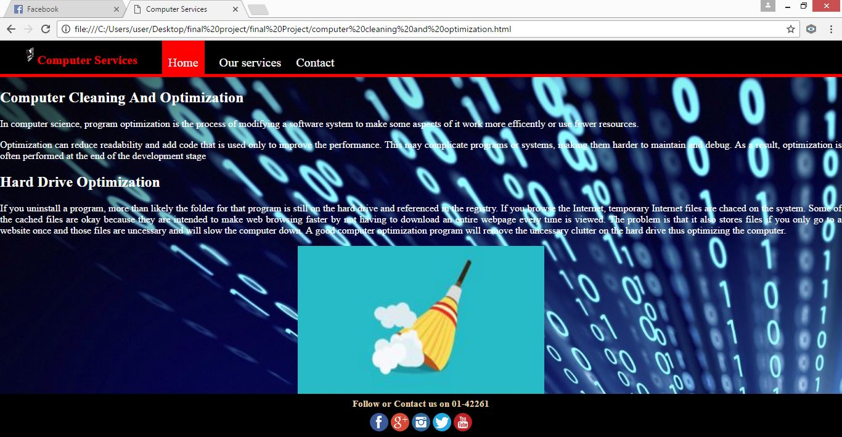

**Fig 6 : Computer Cleaning and Optimization**

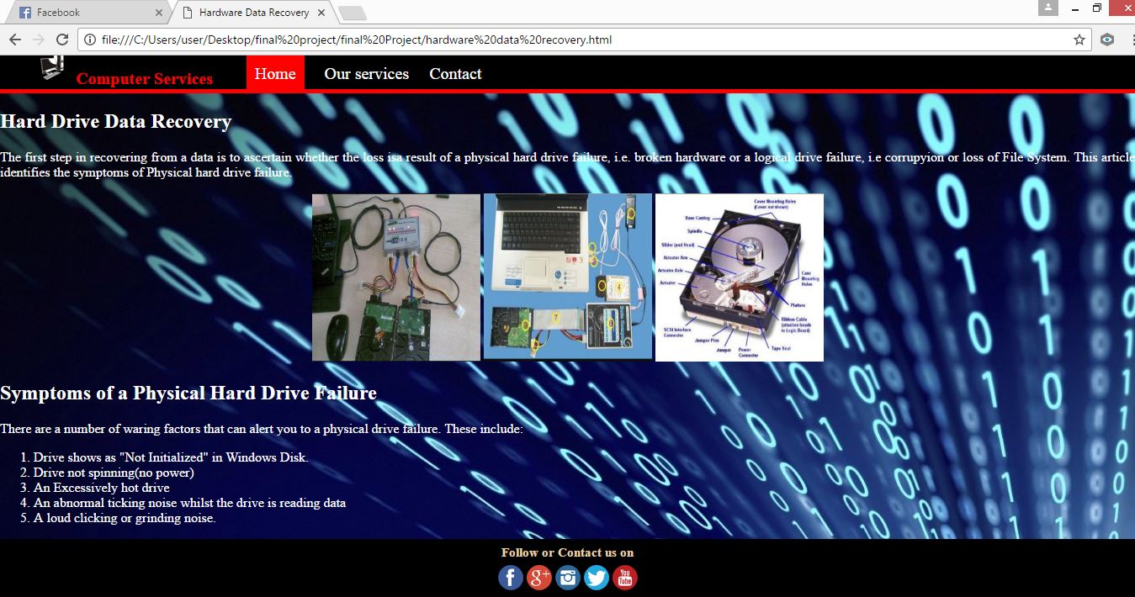

**Fig 7 : Hard Drive Data Recovery**

**Our Services**

**Data Recovery**

<html>

<head>

<title>Hardware Data Recovery</title>

<link rel="stylesheet" href="style.css">

</head>

<body>

<header>

<nav>

<h1><img src="5.jpg" width="50px" height="40px">Computer Services</h1>

<ul id="nav">

<li>

<a class="homered" href="home.html">Home</a>

<a class="homeblack" href="service.html">Our services</a>

<a class="homeblack" href="contact.html">Contact</a>

</li>

</ul>

</nav>

</header>

<div class="divider"></div>

<h2 class="color">Hard Drive Data Recovery</h2>

<p align="justify" class="color">The first step in recovering from a data is to ascertain whether the loss isa result of a physical hard drive failure, i.e. broken hardware or a logical drive failure, i.e corrupyion or loss of File System. This article identifies the symptoms of Physical hard drive failure.</p>

<center>

<img src="10.jpg" width="200px" height="200px">

<img src="9.jpg" width="200px" height="200px">

<img src="11.jpg" width="200px" height="200px">

</center>

<h2 class="color">Symptoms of a Physical Hard Drive Failure</h2>

<p align="justify" class="color">There are a number of waring factors that can alert you to a physical drive failure. These include:

<ol type="1" class="color">

<li class="color">Drive shows as "Not Initialized" in Windows Disk.</li>

<li class="color">Drive not spinning(no power)</li>

<li class="color">An Excessively hot drive</li>

<li class="color">An abnormal ticking noise whilst the drive is reading data</li>

<li class="color">A loud clicking or grinding noise.</li>

</ol>

</p>

<div class="footer">

<h1>Follow or Contact us on</h1>

<br>

<a href="https://www.facebook.com"><img src="face.png" width="30" height="30"></a>

<a href="https://www.google.com"><img src="google.png" width="30" height="30"></a>

<a href="https://www.instagram.com"><img src="instagram.png" width="30" height="30"></a>

<a href="https://www.twitter.com"><img src="twitter.png" width="30" height="30"></a>

<a href="https://www.youtube.com"><img src="youtube.png" width="30" height="30"></a>

</div>

</body>

</html>

**Our Services**

**Website Design and Management**

<html>

<head>

<title>Website Design And Maintenance</title>

<link rel="stylesheet" href="style.css">

</head>

<body>

<header>

<nav>

<h1><img src="5.jpg" width="20px" height="30px">Computer Services</h1>

<ul id="nav">

<li>

<a class="homered" href="home.html">Home</a>

<a class="homeblack" href="service.html">Our services</a>

<a class="homeblack" href="contact.html">Contact</a>

</li>

</ul>

</nav>

</header>

<div class="divider"></div>

<h2 class="color">Website Design And Maintenance</h2>

<p align="justify" class="color">The collection of webpages is known as website. Webpages is the collection of text, audio, video, images etc. </p>

<p class="color">Our services is to design and maintain the website according to your demand or as per your wishes. We design and maintain the website like :

<ul type="disc" class="color">

<li class="color">Business Webiste</li>

<li class="color">School Website</li>

<li class="color">College Website</li>

<li class="color">Institute Website</li>

<li class="color">And many more. For e.g Business Website </li>

</ul>

</p>

<center><img src="70.jpg" height="275px" width="50%"></center>

<div class="footer">

<h1>Follow or Contact us on 01-42261</h1>

<br>

<a href="https://www.facebook.com"><img src="face.png" width="30" height="30"></a>

<a href="https://www.google.com"><img src="google.png" width="30" height="30"></a>

<a href="https://www.instagram.com"><img src="instagram.png" width="30" height="30"></a>

<a href="https://www.twitter.com"><img src="twitter.png" width="30" height="30"></a>

<a href="https://www.youtube.com"><img src="youtube.png" width="30" height="30"></a>

</div>

</body>

</html>

**Output Of Website Desigining and Contact**

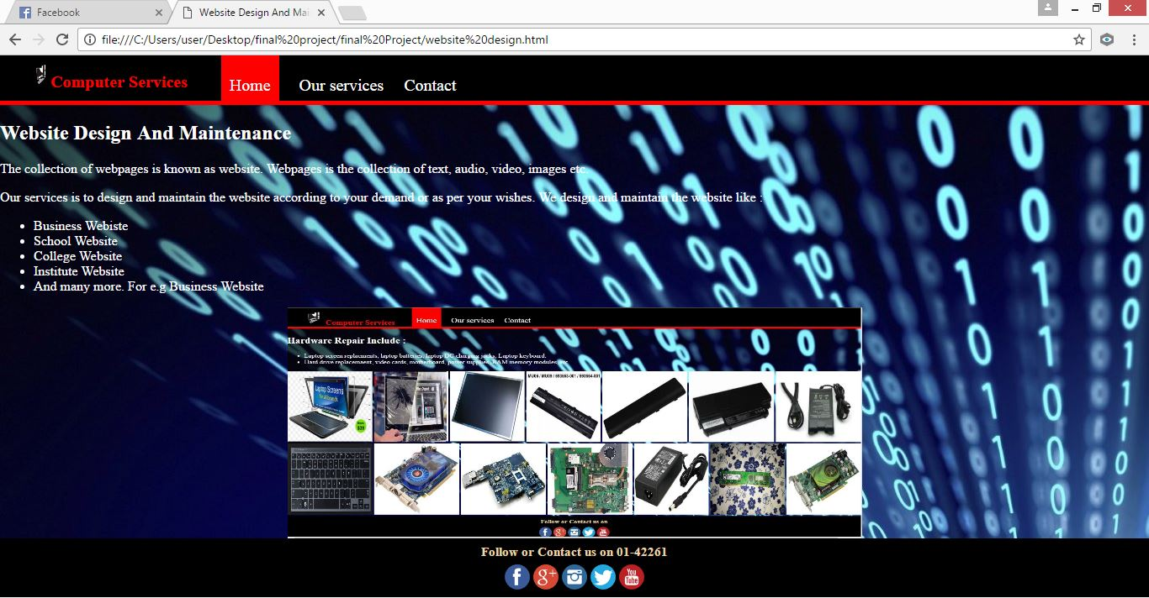

**Fig 8 : Website Desigining**

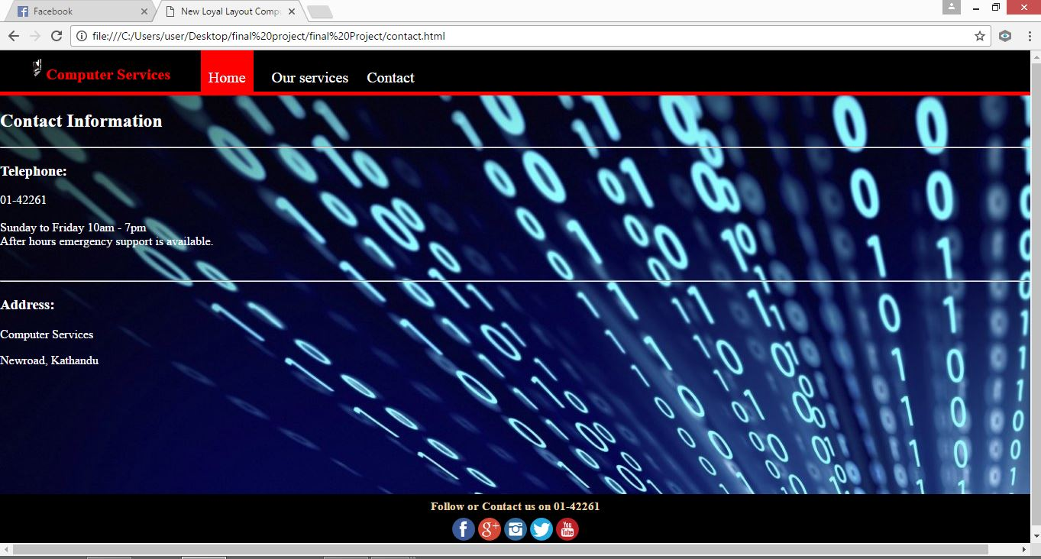

**Fig 9 : Contact Information**

**Contact**

<html>

<head>

<title>New Loyal Layout Computer Repairs Center</title>

<link rel="stylesheet" href="style.css">

</head>

<body>

<header>

<nav>

<h1 ><img src="5.jpg" width="20px" height="30px">Computer Services</h1>

<ul id="nav">

<li>

<a class="homered" href="home.html">Home</a>

<a class="homeblack" href="service.html">Our services</a>

<a class="homeblack" href="contact.html">Contact</a>

</li>

</ul>

</nav>

</header>

<div class="divider"></div>

<h2 class="color">Contact Information</h2><hr>

<h3 class="color">Telephone:</h3>

<p align="justify" class="color">01-42261<br><br>

Sunday to Friday 10am - 7pm<br>

After hours emergency support is available.

</p>

<br>

<hr>

<h3 class="color">Address:</h3>

<p class="color">Computer Services</p>

<p class="color">Newroad, Kathandu</p>

<div class="footerr">

<h1>Follow or Contact us on 01-42261</h1>

<br>

<a href="https://www.facebook.com"><img src="face.png" width="30" height="30"></a>

<a href="https://www.google.com"><img src="google.png" width="30" height="30"></a>

<a href="https://www.instagram.com"><img src="instagram.png" width="30" height="30"></a>

<a href="https://www.twitter.com"><img src="twitter.png" width="30" height="30"></a>

<a href="https://www.youtube.com"><img src="youtube.png" width="30" height="30"></a>

</div>

</body>

</html>

**Style.css**

body{

margin: 0px;

background:url(36.jpg);

height: 100%;

width: 100%;

}

header{

background-color: black;

color:white;

padding: 8px 0px 6px 40px;

width: 100%;

height: 40px;

}

header h1{

color: red;

display: inline;

font-family: Times in new roman;

font-weight: 200px;

font-size:20px;

float: left;

margin-top: 0px;

margin-right: 0px;

}

nav ul{

display: inline;

text-decoration: none;

float: left;

padding: 0px 0px 0px 0px;

}

nav ul li{

display: inline;

list-style-type: none;

color: white;

float: left;

margin-left: 20px;

}

nav ul li a{

color: white;

text-decoration: none;

margin-left: 20px;

font-size: 20px;

}

#nav{

font-family: times in new roman;

}

.homered{

background-color: red;

padding: 30px 10px 13px 10px;

}

.divider{

background-color: red;

height: 5px;

}

.homeblack:hover{

background-color: red;

}

.logo{

float: left;

margin-left: 15px;

padding: 0px 5px 0px 5px;

}

#box1{

width: 400px;

height: 300px;

border:3px groove red;

margin-left: 300px;

margin-top: 10px;

}

.color{

color: white;

}

.footer{

height: 70px;

width: 100%;

background-color: black;

padding: 0px 0px 0px 0px;

margin:0px 0px 0px 0px;

float: left;

text-align: center;

border-left:0px #EAD4AB solid;

border-right:0px #EAD4AB solid;

}

.footer h1{

height:5px;

font-size:15px;

font-family:Times in new roman;

margin:8px 0px 0px 0px;

padding:0px;

color:#EAD4AB;

}

.footerr{

height: 70px;

width: 100%;

background-color: black;

padding: 0px 0px 0px 0px;

margin:150px 0px 0px 0px;

float: left;

text-align: center;

border-left:0px #EAD4AB solid;

border-right:0px #EAD4AB solid;

}

.footerr h1{

height:5px;

font-size:15px;

font-family:Times in new roman;

margin:8px 0px 0px 0px;

padding:0px;

color:#EAD4AB;

}

# Chapter 5 : CONCLUSION:

Hence, this chapter attempts to give conclusion and suggestive result or recommendations to the whole study. The following project work gives information about the HTML in detail and the types of tags and the ways to use those tags.

## 5.1. Lesson Learnt

Through the help of this project we were able to understand the meaning of HTML and the types of tags and the proper way of using those tags to create webpage and design it in an attractive way that can catch the eye of the user very easily.

Thus, through this project we were able to gain more knowledge about creating a webpage and the process used to create it. So, I would like to thank our computer teacher once again for assigning us this project and giving us the chance of acknowledging our skills through this project.

## 5.2. Recommendation

After getting conclusion, we found certain problems that should be solved and I would like to give some recommendations;

1. It should increase the number of qualified computer mechanic.
2. It should give more advertisements.
3. It should provide good environment.

**References:**

* **Dilli Prasad Sharma**, M.Sc. Computer Science-Gold Medalist, Founder Member of Samriddhi college, B.Sc.CSIT Coordinator, Prime College, Faculty Member, Amrit Science Campus, National College of Computer Science(NCCS)
* **Er. Ravi Kumar Singh,** B.E. Computer, PU Head of Department Pentagon International College, Orchid International College, Nagarjuna College of IT
* **Dinesh Khadka,** M.Sc.CSIT, Head of Department, National College of Computer Studies(NCCS), Kathmandu Bernhardt College
* **Karn Dev Bhatta,** M.Sc. Computer Science(MDU), CSIT Program Coordinator, Far Western University, Faculty Member, Siddhanath Science Campus, Western Public Academy
* **Navaraj Baral,** MSCIT, Faculty Member, New Capital College, Sky Rider Higher Secondary School, Chitwan
* **Ramesh Singh Saud,** M.Sc. CSIT, TU, Nagarajuna College of IT(IT Director), Faculty Member, Shanker Dev Campus, Orchid International College, Pentagon International College, Thames InternationalCollege, Samriddhi College
* **Kumar Poudyal,** Master in Computer Application, BSc CSIT Cordinator, New Summit College, Faculty Member, Henry Ford International College
* **Ganesh Prasad Chautaut,** M.Sc.CSIT, TU Bsc CSIT Coordinator, Henry Ford International College, Faculty Member, New Summit College
* **Siddhartha Manu Marasini,** MBS in MIS(TU) Program Coordinator, Thames Int'l College, Faculty Member, Nepal Commerce Campus, College of Applied Business
* **Roshan Dangi,** M.Sc.CSIT Coordinator, Opal College of Applied Management, Faculty Member, Xavier International College, HIMS College, Guiness College, Mahindra Bouddha H.S.S.

**KEC Publication and Distribution**

**Kathmandu, Nepal**

**Internet**

* **https://www.youtube.com/watch?v=_IFO7UEFaiU**